Project Design Phase-II
Technology Stack (Architecture & Stack)

Date | 18 Feb 2026
Team ID | 699ec7849962d99304ab7b76
Project Name | Drishyamitra AI-Powered Photo Management System
Maximum Marks | 4 Marks

Technical Architecture
The Drishyamitra AI-Powered Photo Management System follows a layered architecture where the user interacts with the system through a web or mobile interface. The system processes uploaded images using artificial intelligence and stores them in a cloud database for efficient retrieval and management.
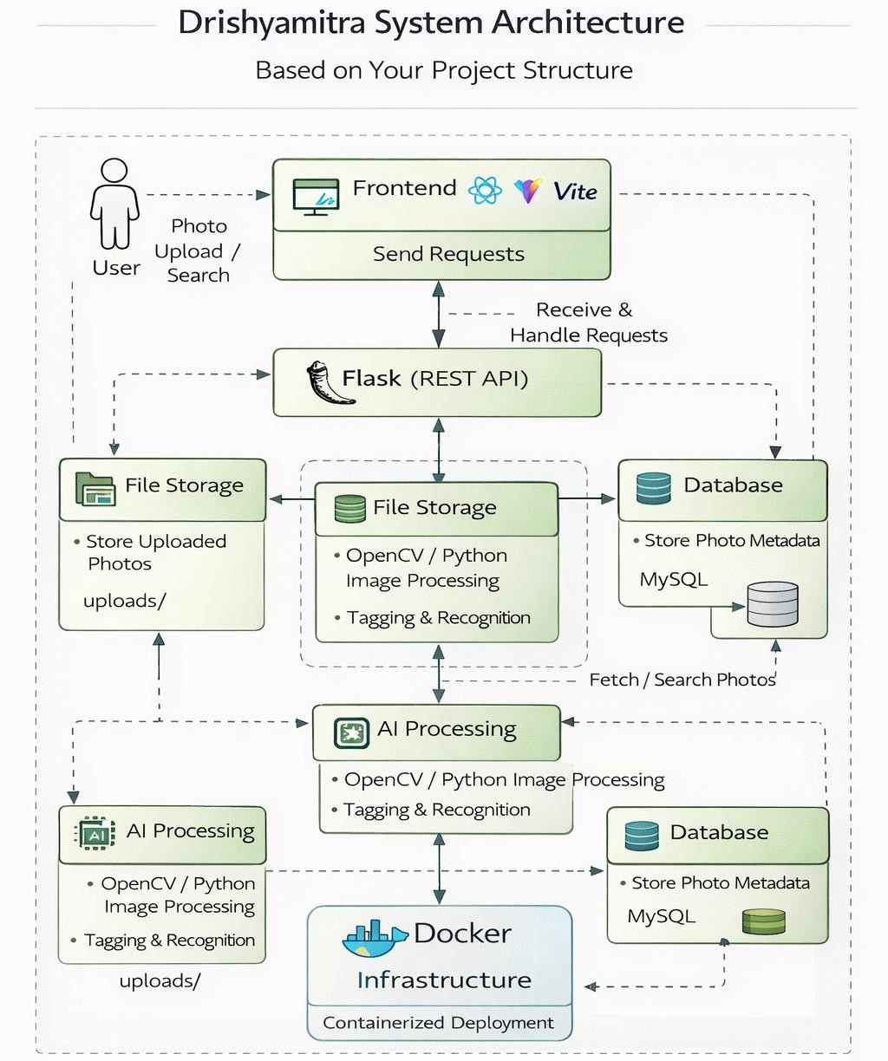
Table-1 : Components & Technologies
S.No | Component | Description | Technology
1 | User Interface | Interface where users interact with the application to upload and search photos | HTML, CSS, JavaScript, React (Vite)
2 | Application Logic-1 | Handles user authentication and request processing in the backend | Python (Flask)
3 | Application Logic-2 | Processes photo uploads and communicates with AI processing modules | Python REST APIs
4 | Application Logic-3 | Performs image analysis and tagging of uploaded photos | OpenCV / Python Image Processing
5 | Database | Stores user information and photo metadata | SQLite / MySQL
6 | Cloud Database | Optional cloud database for scalable deployment | AWS RDS / Firebase
7 | File Storage | Stores uploaded images in the server storage | Local File System (Uploads Folder)
8 | External API-1 | API used for image recognition services | Google Vision API
9 | External API-2 | API used for secure authentication and login | Google OAuth API
10 | Machine Learning Model | Detects objects and faces in uploaded photos | CNN Image Recognition Model
11 | Infrastructure | Platform used for deployment and containerization | Docker

Table-2 : Application Characteristics
S.No | Characteristics | Description | Technology
1 | Open-Source Frameworks | Open-source frameworks used to develop the application | React, Flask
2 | Security Implementations | Security mechanisms used for protecting user data and authentication | JWT Authentication, Environment Variables (.env)
3 | Scalable Architecture | Architecture designed to support increasing number of users and data | REST API Architecture
4 | Availability | System hosted using containerized environment for continuous availability | Docker Deployment
5 | Performance | Optimized frontend rendering and backend API processing | React Optimization, Python APIs

